Nombre de la Práctica #

Autor
Escuela Politécnica Nacional, Facultad de Ciencias
Departamento de Física, Laboratorio de Electromagnetismo
Dd/mm/aaaa
Resumen
Ñawpa pachaka kay ñukanchik kuchu urkuka puñuysikimi kashka. Shinashpa mana kuchu urkukunapash yakuta charinchu. Shuk puncha urkukunapa hatun yaya yakuta tukuy urkukunaman rakikukpi, kay ñukanchik kuchu urkukuna puñukushka nin. Chay urkuka puñuysiki kashkamanta mana yakuta charinchu. Mana puñukushka kashpaka yakuta charinmanmi karka. Chay Mankiwa, Katitawa sikikuna chay Chullku wayku, wichikuna, hutku pashakuna, kay tukuykunami yakuta chariman, mana puñuysiki kashpaka.

Palabras Claves: Ashcu, wambra, llacta, inti, pacha.

Introducción
Ñawpa pachapi, shinami ñukanchik yayakuna nik kashka. Mama Tungurahua urku nishka, yaya Chimborazowan sawarishkami kashka nin. Shinami ishkantikpura kawsakushpa, shuk punchaka, mama Tungurahuaka hatun Kullay urkuwanmi puñunakushka, yaya Chimborazopa washakunapi. Chay Kullay urkuka, imamantapashchari Altar shutiwanmi mishu tsalakunaka riksinkuna [1,2].

Shinapash kariyashka Chimborazoka, mana ima pakashka sakirinchu Inti Yaya ukupika, imashina paypak warmi shuktak urkuwan kawsakushkata riksik chayarkami. Chayta yachashpaka, paypak warmitaka kaspiwanmi wañuchishpa tukuchisha nirka. Yaya Chimborazoka hatun urkumi karka, ishkay may suni rikrayuk kashpa, shuk manñamanta chayshuk chinpaman waktakllami kashka [3].

$f\left(x\right)=a_{0}+\sum_{n=1}^{∞}{\left(a_{n}\cos{\frac{nπx}{L}}+b_{n}\sin{\frac{nπx}{L}}\right)}$ (1)

Kaytami rurayman karka millay urkukunataka; shinapash, utka utkami mana pinkak Kullay urkullatak, Carihuayrasopash warmita mitsankapak chayashkakuna. Shinapash, piñarishka karika, paykuna shamushkata mana rikusha nirkachu; chayllapitak, hatun kaspita hapishpa, Kullaytaka llapishkallami. Chayshuk urkutapash manchanaytami waktashka, pakishka tullukuna illakshina sakinkapak. Shinami ñawpa yayakuna ñukanchikta yachachishka, imamantami Kullay urkuka llapishka sakirishka; shinallatak imamantami Carihuayrasoka, paypak umamanta, chakikamami hatun pakirishka chiktakunata charin [4-7].

$\sin{α}±\sin{β}=2\sin{\frac{1}{2}\left(α±β\right)}\cos{\frac{1}{2}\left(α∓β\right)}$ (2)

Ñawpa pachapi, mama Tungurahua, paypa kusataka manchanaytami kamik kashka, mana paykunashina yuraklla churikunata charishkamanta. Chaymantami mama Tungurahua, tyukashpa kuzuta, kushnita paypak wiksapi tinpuchishpa shitak kashka [4,5].

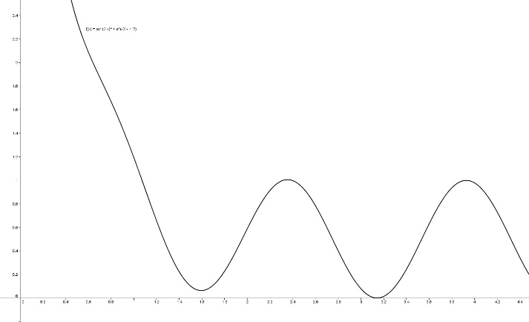 FIG. 1. Ña wiksa paktakta mikushka kipaka, wasiyukkunatami mashkay kallarirkakuna
Kutin yaya Chimborazo (Ec. 1), paypak ukupi kariyashpa, ama shina paypak warmi millay tyukakunawan katichun sakirkachu. Chaymantami, shuk sumak kuitsaka paypak chinkarishka michikunata mashkashpa chayta richun sakishpa. Shinami kuytsaka rurarka (Fig. 1). Chayta purikukpi, paypak chakikunapi shuk sumak, yuraklla kara purututami tarishka. Payka purututa hapishpa, sumakllata rikushpa, apipak chunpi ukupi, warmipak wiksapi sumakllata kunurichun sakishka. Chaypika Pachakamakmi rikurishka [1,3,7-8].

Experimento
Shuk puncha, shuk machashka runa raymimanta tikramukushka Tutami kashka Machashka runaka mayta rishkata mana rikushkachu Chaymanta ñitkashpa, waykuman washikushka Urmashpaka shuk yura rikrapi warkurishka sakirirka Tukuy tuta, manchaklla kaparikushkarkami.

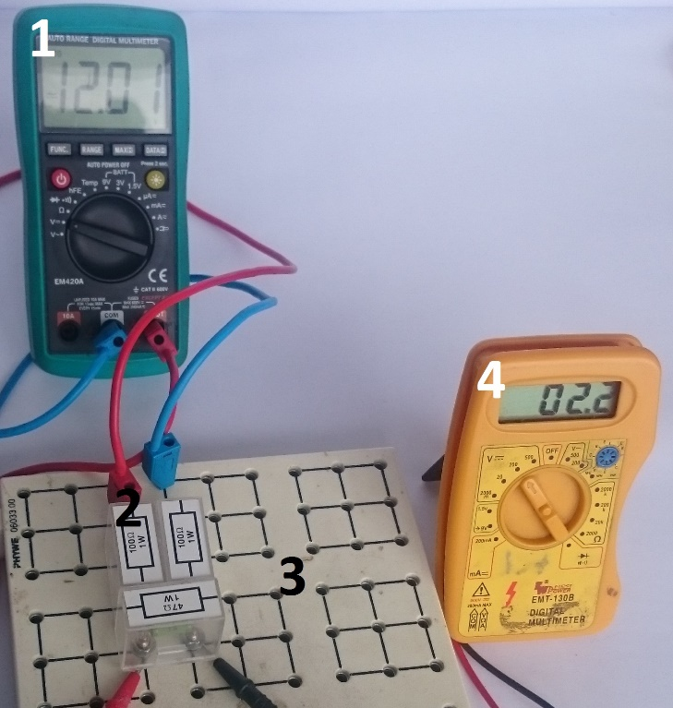
FIG. 2. (1) Ña wiksa paktakta mikushka kipaka, wasiyukkunatami mashkay kallarirkakuna nti achikyamukta rikushpaka; (2) Hawa wichiyana kaspipi; (3) Kashpaka shuk wakcha runaka; (4) Pakalla rimashkatami kashna nikta uyarka.

Yanapaychik, Pi mana uyarkachu. Machaskaka sinchita charirirkami. Ama (Fig. 2) chaypi wañunkapak paypak yanapakkunata mañarkami machashkaka achka shaykushka shina warkurishkami pakarirka ma achiyarikpi, inti achikyamukta rikushpaka, machashkaka manchanayta shaykushka kashpa, urayman rikurka paypak chakika iñullamanta mana pampaman chayashka karka.

Paykunaka yarikaywan wañukushpami, imallatapash mikuchunpishchari nishpa allimanta punkuta paskay kallarirkakuna; shinami ukuman yaykurkakuna. Yanuna ukupika kara mutishkami tiyakushka hatun mankakunapi. Chayta rikushpaka yarikaywan kashpaka mikuy kallarishkakunami. Ña wiksa paktakta mikushka kipaka, wasiyukkunatami mashkay kallarirkakuna. Mana ima rikurikpika shitashka wasi shinami rikurirka. Chay kipaka hawa kawsanamanmi wichiyarkakuna.

Ña amsa kakpika manchanachikushpallatak chayman kallparkakuna, chayashpaka punkupi waktarkakuna; shinapash mana pi punkuta paskanaman llukshirkachu la pakarimukukpimi alli, alli rikurkakuna mana runa kashkata, kaykunaka kimsa charik pumakunami kashka karka, kaykunataka rikushpaka kaspikunata, sawllikunata hapishpa, kay pumakunataka wañuchishpa shitashka nin. Shinami chay mana imata charik wakcha runakunaka achka chariyuk tukurkakuna.

Tiempo [s] | Temperatura [k] | Error [%] | Desviación estándar [k]
1 | 372 | 1.2 | 2.2
2 | 380 | 15.2 | 14.2
3 | 385 | 3.4 | 6.6
4 | 388 | 6.9 | 7.9
5 | 391 | 52.8 | 9.8
6 | 391 | 1.9 | 2.2
7 | 391 | 32.8 | 2.3
8 | 395 | 7.7 | 5.4
9 | 400 | 9.8 | 15.2
10 | 401 | 15.8 | 14.6
11 | 412 | 33.3 | 0.123
TAB. 1. Chinami ishkantikpura kawsakushpa, shuk punchaka, mama Tungurahuaka hatun Kullay urkuwanmi puñunakushka ya borazopa washakunapi.

Ñawpa pachapi, shuk may sumak hatun wasipi kimsa runakuna kawsashka nin. (Tab. 1) Paykunaka achka sara takikunata charishka, charishkapashmi tawka piña allkukunata, wasita rikuchun, muyuchunpash. Shuk kutinmi, ishkay wakcha runakuna mana imata charishpa, mana imata mikuy tukushpa, ñanta hapishpa puri kallarishkakuna. Purikushpa, purikushpa, ña shaykurkakuna, chaypi samayta kallarirkakuna. Ña samashka kipaka, chinpa urku sikipi shuk pakalla nina rupakukta rikurkakuna nin.
Resultados y discuSión

Ñawpa pachapi, shuk may sumak hatun wasipi kimsa runakuna kawsashka nin. Paykunaka achka sara takikunata charishka, charishkapashmi tawka piña allkukunata, wasita rikuchun, muyuchunpash (Ec. 2). Shuk kutinmi, ishkay wakcha runakuna mana imata charishpa, mana imata mikuy tukushpa, ñanta hapishpa puri kallarishkakuna. Purikushpa, purikushpa, ña (Ec. 1) shaykurkakuna, chaypi samayta kallarirkakuna. Ña samashka kipaka, chinpa urku sikipi shuk pakalla nina rupakukta rikurkakuna nin. .Ñawpa pachapi, shinami ñukanchik yayakuna nik kashka. Mama Tungurahua urku nishka, yaya Chimborazowan sawarishkami kashka nin. Shinami ishkantikpura kawsakushpa, shuk punchaka, mama Tungurahuaka hatun Kullay urkuwanmi puñunakushka, yaya.

FIG. 3. Ña wiksa paktakta mikushka kipaka, wasiyukkunatami mashkay kallarirkakuna

Paykunaka yarikaywan wañukushpami, imallatapash mikuchunpishchari nishpa allimanta punkuta paskay kallarirkakuna; shinami (Fig. 3) ukuman yaykurkakuna. Yanuna ukupika kara mutishkami tiyakushka hatun mankakunapi. Chayta rikushpaka yarikaywan kashpaka mikuy kallarishkakunami. Ña wiksa paktakta mikushka kipaka, wasiyukkunatami mashkay kallarirkakuna. Mana ima rikurikpika shitashka wasi shinami rikurirka. Chay kipaka hawa kawsanamanmi wichiyarkakuna. Ña hawa wichiyana kaspipi kashpaka shuk wakcha runaka, pakalla rimashkatami kashna nikta uyarka.

$$a^{2}=470 [mg]$$

Shuk puncha, shuk machashka runa raymimanta tikramukushka. Tutami kashka. Machashka runaka mayta rishkata mana rikushkachu. Pi mana uyarkachu. Machaskaka sinchita charirirkami. Ama chaypi wañunkapak paypak yanapakkunata mañarkami. Machashkaka achka shaykushka shina warkurishkami pakarirka. Ña achiyarikpi, inti achikyamukta rikushpaka, machashkaka manchanayta shaykushka kashpa, urayman rikurka. Paypak chakika iñullamanta mana pampaman chayashka karka.

Conclusiones

Yaya Imbaburaka kashnami kashka Wakrakunatami ñawpa pachapi sapan wasipi charik kashka Chayshuk taytakunaka charishka nin shuk kuyashka wakraku kashka nin; shuk sumak shutiwan wakrataka shutichishkakuna nin. Shina wakrata shutiwan kayakpika payka ninanta kallpashpa shamuklla kashka nin.

Ña yaykushkalla nin chay punkuruku paskarikpika ña yaykukukpika ashta ukupi patsak achka manchanayay hatun allparuku kashka nin; pay kurikunawan hatun allparuku ashta ninan ninan hatun allparuku; ashta kiwakunapash paymanta kuyukuk, runakunapash kaymanta chaymanta ñuñuta kapishpa ashta hatun allparuku kashka nin.

Kanchaman llukshishpa rikukrikpika ashta kurilla kashka nin, kurilla miklla huntashka nin taytakuka. Chayka tukuylla chay killimsa kanllaman llukshishpa rikukrikpika, kurilla kashka nin. Chayta ashta shinallatak ashta pay killimsapachaka maypishi hicharayakushkallami nin, shina kurichu karkari. Payka kay kullkita hapishpaka kurintinmi wasiman tikrashka nin Blah.

BIBLIOGRAFÍA

[1] N. Sourial-Bassillious, A.-C. Eklöf, L. Scott, A. Aperia, and S. Zelenin, “Effect of TNF-α on CD3-ζ and MHC-I in Postnatal Rat Hippocampus,” vol. 60, pp. 377–381, 2006.
[2] R. Moya and F. Jara, taruka-Literatura-Oral-Kichwa, Tercera. Quito: DIrección Nacional de Educación Intercultural Bilingüe del Ecuador, 2009.
[3] H.-K. Lau and M. B. Plenio, “Universal Quantum Computing with Arbitrary Continuous-Variable Encoding,” Phys. Rev. Lett., vol. 117, no. 10, p. 100501, Aug. 2016.
[4] A. Gibbons, “Ancient DNA divide.,” Science, vol. 352, no. 6292, pp. 1384–7, Jun. 2016.
[5] H. Wei, F. Liang, G. Meng, Z. Nie, R. Zhou, W. Cheng, X. Wu, Y. Feng, and Y. Wang, “Redox/methylation mediated abnormal DNA methylation as regulators of ambient fine particulate matter-induced neurodevelopment related impairment in human neuronal cells,” vol. 6, p. 33402, 2016.
[6] M. S. P. Reddy and C. Park, “Bright luminescence from pure DNA-curcumin–based phosphors for bio hybrid light-emitting diodes,” vol. 6, p. 32306, 2016.
[7] C. C. Bouuaert, S. Keeney, I. Lam, S. Keeney, G. Bloomfield, N. Vrielynck, T. Robert, K. D. Corbett, P. Benedetti, J. M. Berger, S. Keeney, C. N. Giroux, N. Kleckner, A. Bergerat, F. Baudat, and B. de. Massy, “DNA. Breaking DNA.,” Science, vol. 351, no. 6276, pp. 916–7, Feb. 2016.
[8] F. J. Meye, M. Soiza-Reilly, T. Smit, M. A. Diana, M. K. Schwarz, and M. Mameli, “Shifted pallidal co-release of GABA and glutamate in habenula drives cocaine withdrawal and relapse,” vol. 19, pp. 1019–1024, 2016.

